SARS-CoV-2 Variants Analysis

Objectives

After discussing with Professor Jo Youngji, we realized that combining the two topics into a single discussion is challenging. The first topic—using the initial growth rate of COVID-19 variants to predict their dominance—is already complex, particularly in terms of the modeling aspects. Therefore, we have decided to address them as two separate research topics. The main points are as follows:

First Analysis
Main topic: How much early share growth rate can predict the future share dominance (general model).
Deliverable goals:
- To evaluate the prediction performance (maximum and duration) of the model.
- To determine the range of growth rates most contributing to the dominance. (by the coefficient)
Utility of the model: our model can predict the future dominance by monitoring the share growth rate of the new variant, based on the specific growth rate before reaching the threshold (20%).

Methods

Sample Collection and Definitions. The GISAID (Global Initiative on Sharing All Influenza Data) COVID-19 collection serves as a vital global repository for SARS-CoV-2 genomic data, enabling researchers worldwide to track the virus's evolution, transmission, and mutations. Since its launch in January 2020, GISAID has been regularly updated with submissions from various countries, showcasing collaborative efforts in combating the pandemic. Notably, nations such as South Korea, the United Kingdom, and the United States have contributed extensively to the database, reflecting their robust genomic surveillance programs. Data is collected through a network of participating laboratories, public health institutions, and universities, where clinical samples are sequenced and analyzed before being uploaded to the platform. Institutions such as the Korea Disease Control and Prevention Agency (KDCA), the UK Health Security Agency (UKHSA), and the Centers for Disease Control and Prevention (CDC) in the U.S. play pivotal roles in their respective countries' contributions. GISAID remains a cornerstone of international cooperation, fostering transparency and accelerating research aimed at understanding and mitigating the global impact of COVID-19.

The GISAID dataset utilized in this study comprises infection counts from over 3,000 SARS-CoV-2 lineages across the top 30 countries with the highest cumulative infection counts, spanning the period from January 2020 to May 2024. This dataset is recorded daily, enabling detailed day-level analysis of the pandemic's progression and variant-specific impacts. For the purposes of this research, we focus primarily on these top 30 countries, defined by their total COVID-19 infection cases, as they provide the most comprehensive and impactful data for understanding the global dynamics of the pandemic. By concentrating on these countries, the analysis gains greater relevance and precision, reflecting the regions with the most significant epidemiological and public health implications. This targeted approach allows for deeper insights into the interplay between variant evolution, infection trends, and geographic-specific factors, making the findings highly valuable for both global and regional pandemic responses.

Inclusion/Exclusion criteria.
In the variants’ dominance prediction analysis, to enhance representativeness, we classified over 3,000 SARS-CoV-2 lineages based on their parent lineages and ancestors. The goal of this classification was to aggregate the vast number of individual lineages into a manageable set of representative groups, ensuring that each classified lineage reflected a broader category of related lineages. To focus on the most epidemiologically and clinically relevant variants, we established specific criteria for inclusion in the classified lineages. Each lineage had to have recorded at least 500 infections by August 2022, and its peak prevalence within a country had to account for at least one percent of total infections. These thresholds ensured that the selected lineages were significant contributors to the pandemic's trajectory in their respective regions.

Using these criteria, for the top 30 countries with the highest COVID-19 infections, the over 3,000 lineages were condensed into 22 representative lineages. These include well-known variants such as B.1.1.7 (Alpha), AY.4 (Delta), BA.5 (Omicron), XBB.1 (Omicron), and JN.1, among others. The selection covers key lineages that played pivotal roles in the global spread of the virus. Most of the 30 countries included in the analysis contained all 22 classified lineages, reflecting their widespread impact. However, the start dates for lineage detection and prevalence varied by country, highlighting differences in the timing and spread of these lineages across regions. The following table1 gives a general view of the different situation of the different countries among them.
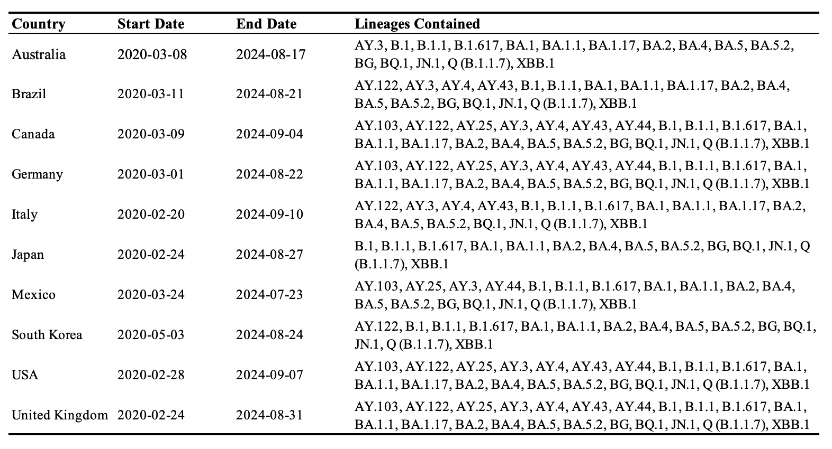
Table1: Description Table of the GASID Data

Statistical Methodologies (Dominance Prediction).
In the analysis of variant dominance prediction, a critical step is defining "dominance." Common definitions include the average country-level share of a lineage or its maximum share during a specific period. The use of country-level share is essential to address the population differences between countries, which could otherwise skew the analysis. In this analysis, we assessed the dominance of the variant from two perspectives: the maximum share of infections and the duration of the epidemic wave. An epidemic wave is defined as a period with at least seven consecutive days of reported infections, starting on the first day of this sequence and ending on the last day before a subsequent seven-day period with no reported cases. These two measures together provide a comprehensive characterization of the variant’s dominance, as the maximum share reflects the peak prevalence of the variant relative to others, while the duration of the epidemic wave captures how long the variant maintained active transmission within the population.

In our analysis, the ‘initial stage’ is defined using a flexible observation period. We set a threshold for variant share (20% in our case) and a maximum observation window of 30 days. Specifically, if a variant reached the 20% share threshold within 30 days, only the period prior to reaching that threshold was considered its initial stage. Otherwise, the full 30-day period was used. Notably, some variants reached the 20% threshold very rapidly (within ≤ 7 days, which is the minimum observation window), providing insufficient information for reliable forecasting. These variants were excluded from our prediction model, as their swift rise in prevalence indicated a clear dominance that did not require predictive modeling. The impact of selecting different values for the share threshold, maximum observation window, and minimum observation window on the number of samples included in the prediction model is illustrated in Figure 1.

To calculate the growth rate, we first fitted a generalized additive model (GAM) to the time series of each variant’s share during its initial stage in each country. The growth rate was then obtained by taking the derivative of the fitted model. Since the lengths of these growth rate sequences varied across variants, each sequence was transformed into a density curve, which served as a primary input to the prediction model. In parallel, information on the scale was captured by calculating the mean share during the initial period.

The prediction model was constructed using a functional data regression approach (FDA) [Functional Data Analysis, J.O. Ramsay; R package {fda}], which extends traditional regression methods by allowing coefficients to vary continuously — treating them as functions rather than fixed values. By representing growth rate sequences as density curves, we avoided alignment issues caused by the differing timing of variant growth. This transformation shifts the modeling focus from chronological time to the distributional scale of growth rates, enabling the use of FDA with scale-varying rather than time-varying coefficients. This approach enhances interpretability and more effectively captures variations in growth dynamics across different variants.

It is important to note that, prior to model fitting, the data were randomly split into a training set (80%) and a test set (20%). The model was trained exclusively on the training set, while the evaluation metric, R², was computed on the test set. This out-of-sample evaluation provides a more robust and unbiased assessment of model performance, as it reflects the model’s ability to generalize to unseen data, simulating real-world prediction scenarios.

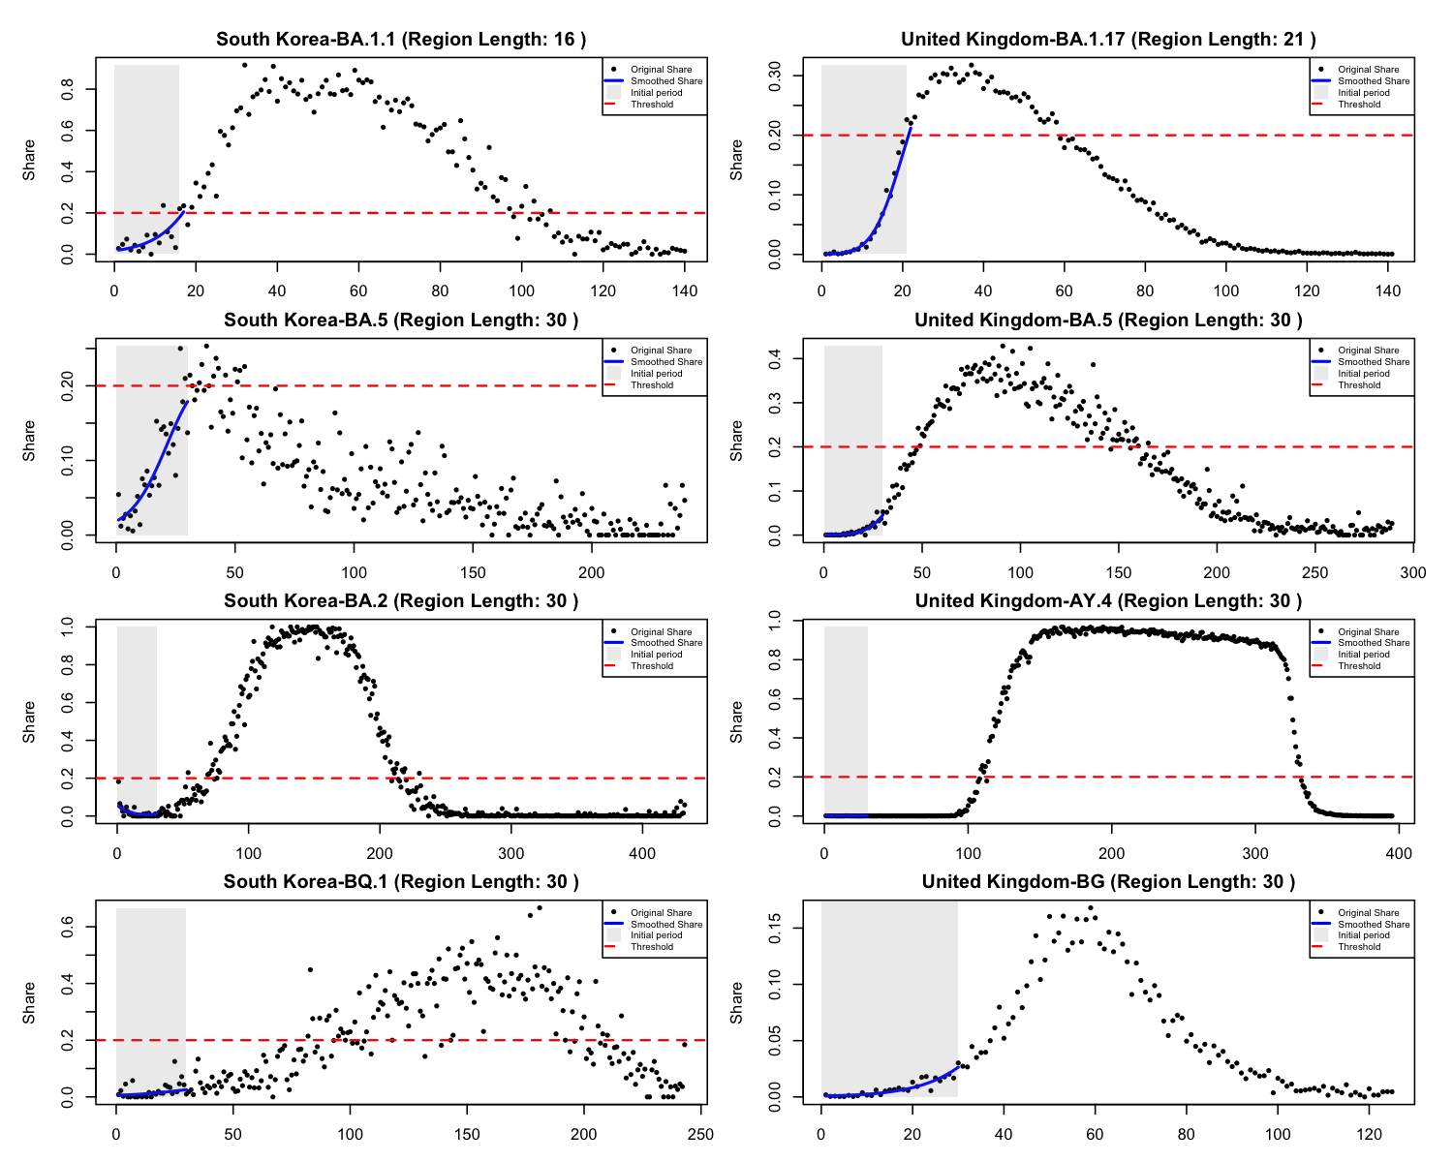
Figure 2: Selection of Initial Period for Variants Using a Flexible Observation Window.

Results (1st Analysis)
Adjustment of the initial stage involved removing irrelevant or uninformative data points at the beginning of each variant’s time series to ensure that the 30-day observation window captured more meaningful and informative data. Following this adjustment, all variants that did not meet the minimum observation window criterion (7 days) were excluded from the analysis. As a result, the number of usable samples decreased from 515 to 388 variants. Figure 2 illustrates examples of how the flexible observation period was selected and how the smoothed growth rates of variant share were calculated. In each panel, the black points represent the original daily share of the variant, while the blue curve shows the smoothed share. The shaded area indicates the initial period defined for each variant.

Let $C_{L}$ and $C_{U}$ denote the lower and upper bounds of the growth rate across all variants and let${ C}_{r}=(C_{L}, C_{U})$ represent the range of growth rates. Let $x_{i}(c)$ denote the density function of the growth rate for the $i^{th}$ variant and $z_{i}$ represent the mean share during the initial period for the $i^{th}$ variant. The functional regression model then follows the standard form introduced in Ramsay’s work:
$$g(E\left[y_{i}\right])= β_{1}z_{i}+ \int_{C_{r}}{x_{i}\left(c\right)β_{2}\left(c\right)dc}$$
Here, $β_{1}$ captures the effect of the mean initial share $z_{i}$ on the response variable $y_{i}$, while $β_{2}(c)$ represents the functional coefficient (generated via Fourier basis in our analysis [REF]) that quantifies the contribution of the growth rate density $x_{i}(c)$, at each value $c$ within the range${ C}_{r}$. Since the assessment of variant dominance is based on two perspectives—the maximum share of infections and the duration of the epidemic wave—the response variable $y_{i}$ can represent either the maximum share or the duration.

There are several terms to be tuned to achieve a good functional regression model: the density of the grid and the number of Fourier basis to select. The tuning process is detailed in the Appendix. The final model predicting the maximum share categories achieved an R² of 0.68 (AIC = 240.1, BIC = 285.8), while the model predicting duration attained an R² of 0.53 (AIC = 4353.8, BIC = 4384.3). The estimated functional coefficients, along with their 90% confidence bands, are presented in Figure 3. The confidence bands were generated by simulating 1,000 sets of coefficients from a multivariate normal distribution using the estimated Fourier coefficients and their covariance matrix and then computing the corresponding fitted curves.
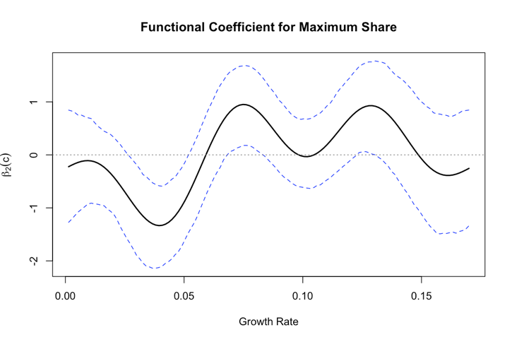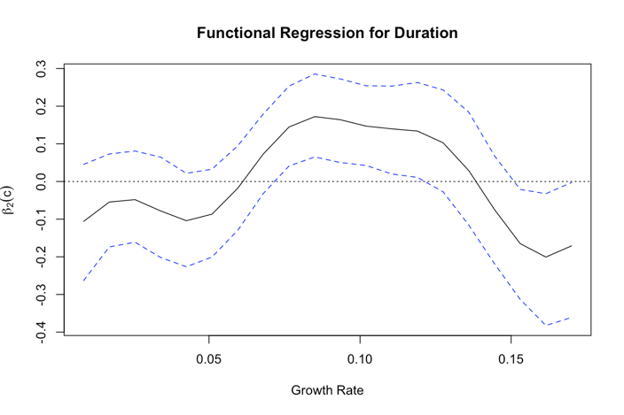
Figure 3: Fitted growth rate coefficients $β_{2}(c)$ for maximum and duration models

The results suggest that a higher proportion of growth rates around 7% and 12% during the initial period contributes significantly and positively to the maximum share of the variant. In contrast, lower growth rates show significantly negative (especially at 3~4%). For the duration model, growth rates between 7% and 12% during the initial period have a significantly positive effect on the duration of the variant. Conversely, growth rates exceeding 15% during the initial period are associated with a negative contribution to variant duration.

To provide a clear assessment of the model’s performance across different variants, we present scatter plots (Figure 4) for each variant. In each panel, the x-axis represents the actual observed values, while the y-axis represents the corresponding predicted values. A reference diagonal line is included to indicate perfect agreement; predictions that lie closer to this line suggest higher accuracy for the given variant. Similarly, we generated the same set of scatter plots (Figure 5) by country to evaluate model performance across different geographic regions. The plots indicate that the model encounters difficulties in accurately predicting variants for which the maximum share reaches exactly 100% in several countries.

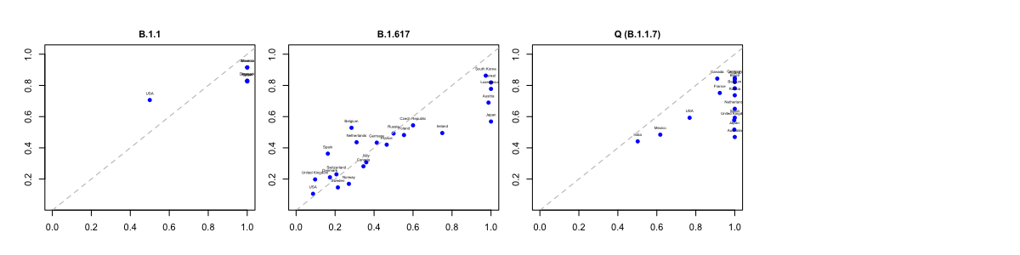
(a) Epidemic Wave 1&2 (Dec 2019 – mid 2021)
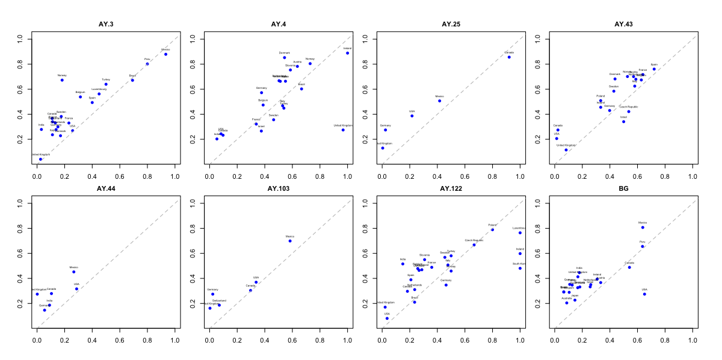
(a) Epidemic Wave 3 (mid 2021 – late 2021)
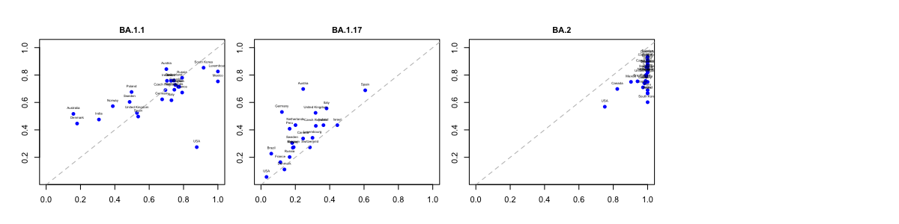
(a) Epidemic Wave 4 (late 2021 – early 2022)
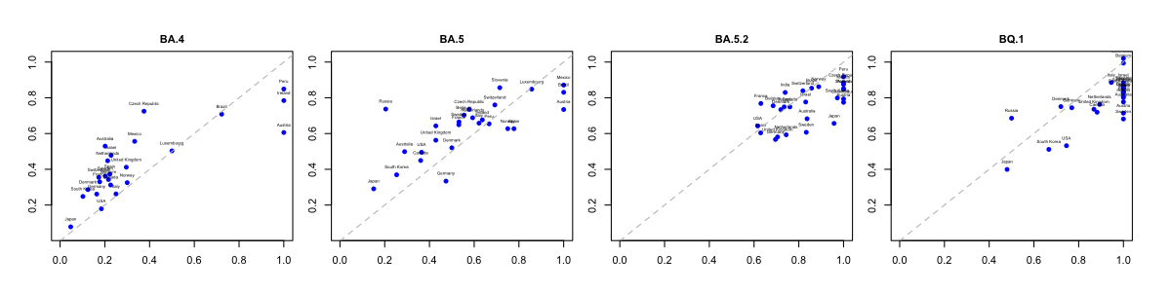
(a) Epidemic Wave 5&6 (mid 2012 – mid 2023)
Figure 4: Actual vs. Predicted Maximum Share, Stratified by WHO-Defined Epidemic Waves

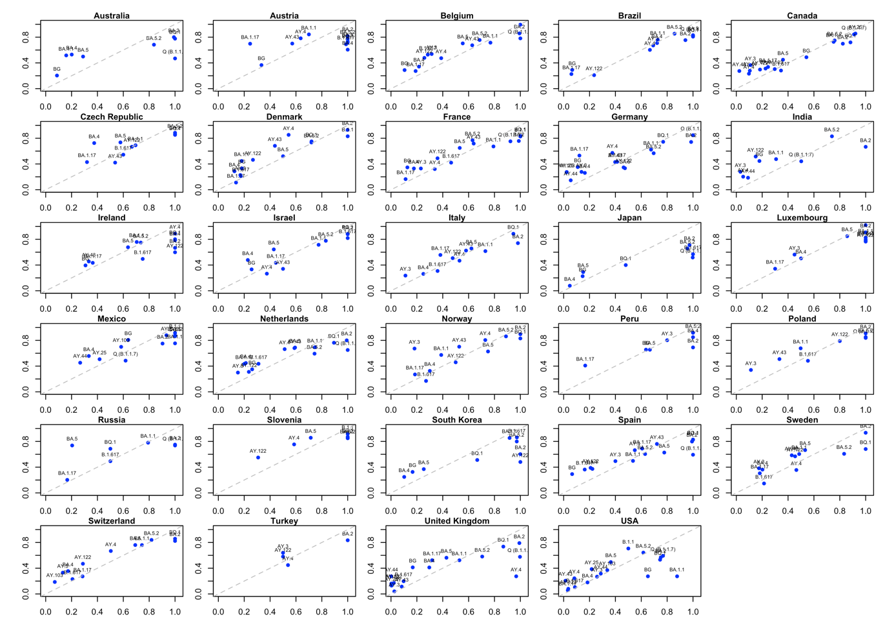

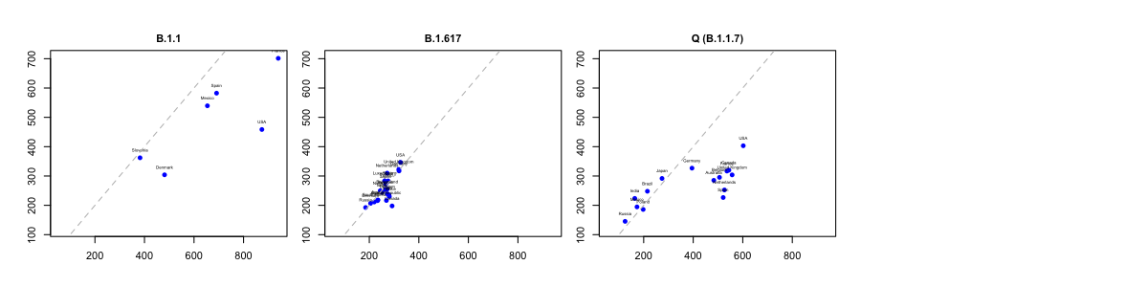
(a) Epidemic Wave 1&2 (Dec 2019 – mid 2021)
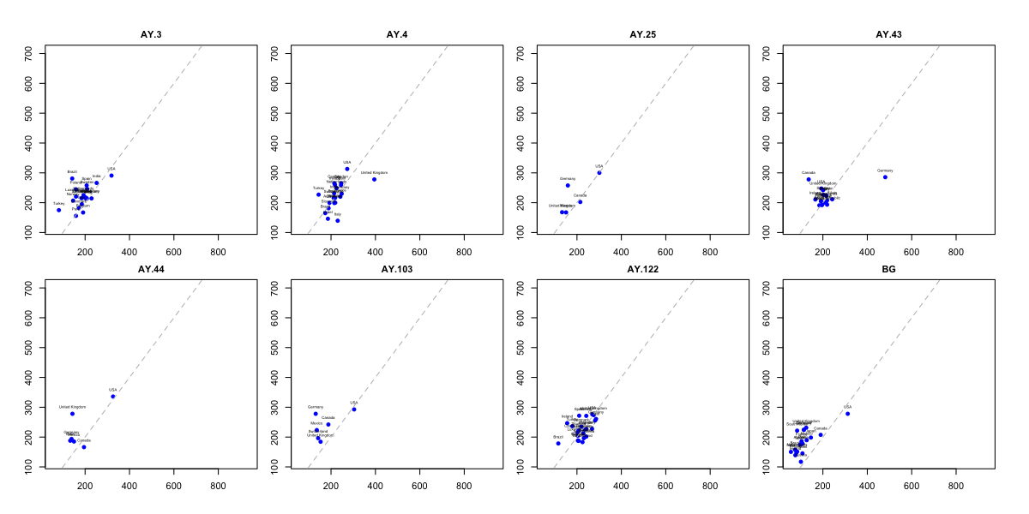
(a) Epidemic Wave 3 (mid 2021 – late 2021)
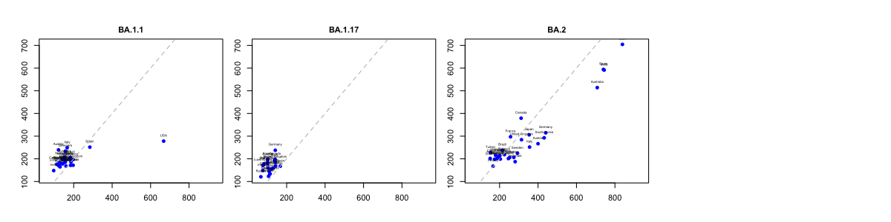
(a) Epidemic Wave 4 (late 2021 – early 2022)
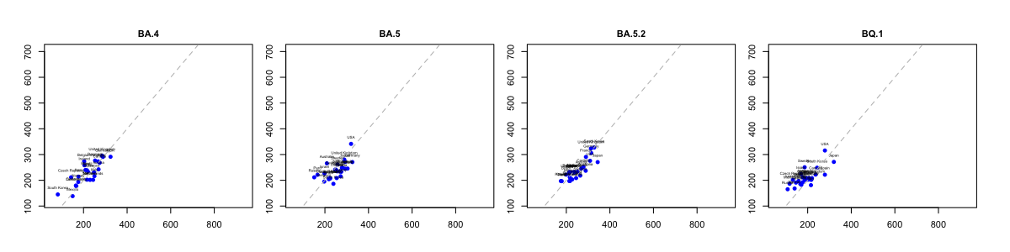
(a) Epidemic Wave 5&6 (mid 2012 – mid 2023)
Figure 6: Actual vs. Predicted Duration, Stratified by WHO-Defined Epidemic Waves

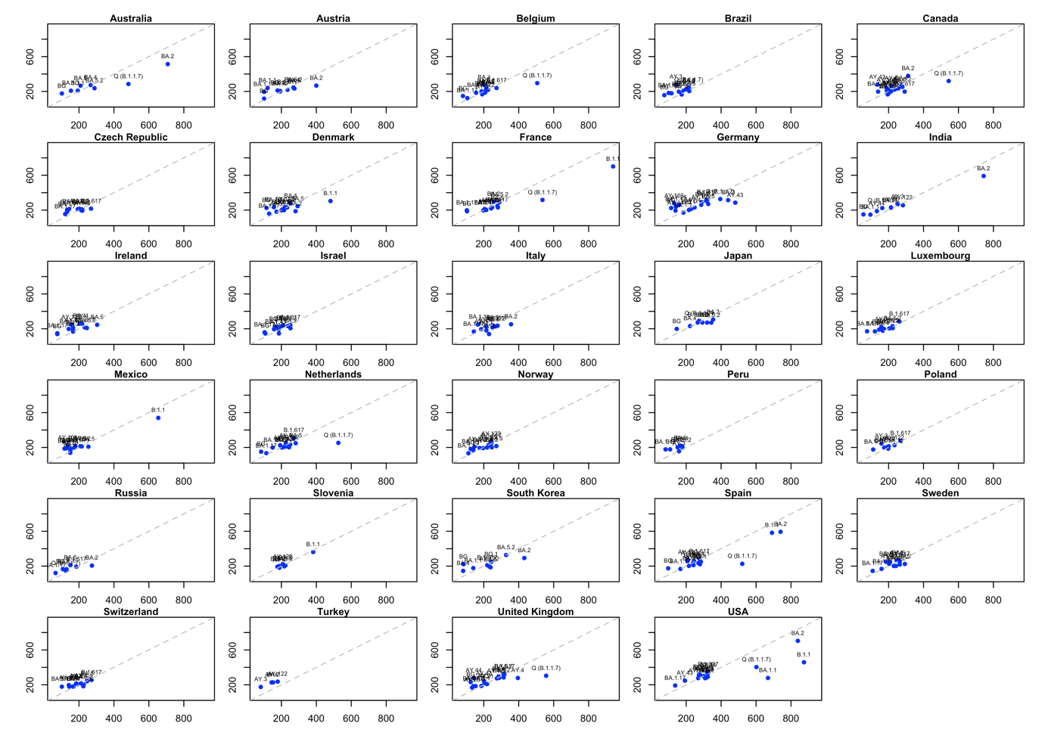
Figure 4: The fitted duration of share (x axis) vs. the actual duration of share (y axis) by variant and country.

Results (2nd Analysis)

This analysis utilizes the time series of variant shares to predict the hospitalization-infection rate. The problem is framed as a standard high-dimensional time series prediction task. The model applied here is ARIMAX, and the prediction results for example countries are presented below. It is worth noting that the time range of hospitalization records varies significantly between countries. For example, in South Korea, records began in November 2021, while in the United Kingdom, they started as early as April 2020.
To combine these two analyses, I created plots where the x-axis represents the dominance of the variants, and the y-axis represents the coefficient of each variant in the ARIMAX model. These coefficients can be interpreted as the contribution of each variant to the hospitalization-infection rate prediction model. A higher y-value indicates a greater contribution to the hospitalization-infection rate. It is common for variant types to differ across countries. For example, JN.1 appears in the United States but not in South Korea or the United Kingdom, primarily due to the differing time ranges of data collection in each country. From the results, we can know that the most hospitalization-infection rate contributed variants are not necessarily to be dominant.

We are considering writing the first analysis as one paper and the second analysis as another separate paper. However, I am uncertain whether the content of the second analysis is substantial enough to stand alone as an independent publication. I would greatly appreciate any comments or suggestions on this matter, including advice on whether and how these two analyses could be effectively combined into a single cohesive paper. Thank you.

